**PwC Switzerland**

**Power BI Virtual Case Experience**

1. **Introduction:**

* **Background information:**

All in on digital transformation: Creating a stronger, nimbler, more resilient future!

We aim to build innovative technology solutions that differentiate us from our competitors and digitise the business. Part of that included a strategic decision to invest in upskilling programmes so our people could learn how to use digital tools for data visualisation as well as automation, data cleansing and more.

If our people could use these tools to solve common problems, they’d help us become more efficient and growth-oriented now and more innovative later in Business Services and beyond. Now, employees are learning to build bots – over 2,400 have been created so far – to automate workflows. We continue to invest to make processes more intuitive using machine learning, PowerBI and eventually artificial intelligence (AI). These are key to working faster and solving problems differently for ourselves and our clients.

This is why you're here! Our Digital Accelerator programme is an internal chance that takes groups of our employees out of their day jobs and puts them through trainings that teaches them skills in technology such as automation, machine learning, design thinking, and digital storytelling. PowerBI is an important part of it as visualising data helps to handle and understand clients.

So, become a Digital Accelerator yourself and start your PowerBI journey with us!

1. **Call Centre Trends (Visualising customer and agent behaviour)**

* **Background information:**

The digital revolution and our fast-changing world requires a skills revolution. And it’s not just about the digital skills. The skills revolution is about helping people build their digital awareness, emotional intelligence and creativity to fully participate in the digital future workplace — and it needs to start now.

At PwC, we are working with other organisations across the world, building on our work with clients and on upskilling our 276,000 people. Still, more must be done if we are to ensure everyone has the opportunity to learn, work and participate in the digital world. This is at the heart of our [purpose](https://www.pwc.com/gx/en/about/purpose-and-values.html).

We are enabling employees who are motivated to further accelerate their skills to do so by offering them a “career pivot” to become what we call “Digital Accelerators”. Accelerators rapidly deepen their skills in digital specialties, such as data, automation, AI, and digital storytelling by learning a variety of self-service tools and coding languages and applying these skills across our business.

We're happy you joined us, welcome to the team! Giulia is your manager and helps you through your upskilling journey in PowerBI - your step to become a true data jedi and Digital Accelerator. But wait no more, word spreads fast and an important client reached out to you to help him visualising their data.

* **Task:**

It’s omnipresent: telecom marketing. Better price here. Better service there. Best for small businesses here. Best for young urbanites there. But what do customers really want? Our client, a big telecom company needs to know. This email just arrived for you:

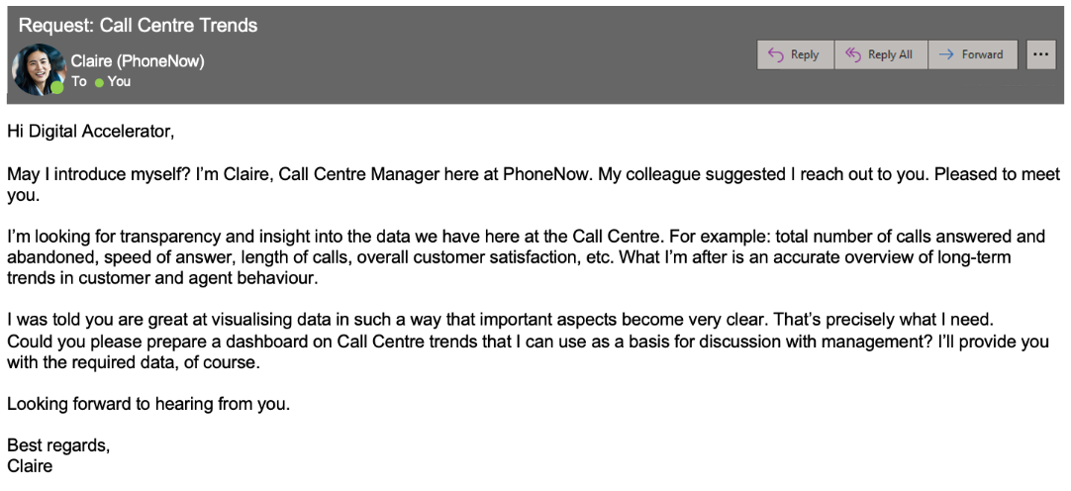

Create a dashboard in Power BI for Claire that reflects all relevant Key Performance Indicators (KPIs) and metrics in the dataset. Get creative!

**Possible KPIs include (to get you started, but not limited to):**

* Overall customer satisfaction
* Overall calls answered/abandoned
* Calls by time
* Average speed of answer
* Agent’s performance quadrant -> average handle time (talk duration) vs calls answered

Do you want to learn more? Level up by listening to a portion (or all!) of our podcasts linked below and read our articles.

**Podcasts**

* [PwC's Tech While You Trek: Data Visualization](https://pwctechwhileyoutrek.buzzsprout.com/1150349/4885124-pwc-s-tech-while-you-trek-data-visualization)
* PwC's [Tech While You Trek: PwC's Digital Upskilling Journey](https://pwctechwhileyoutrek.buzzsprout.com/1150349/5001527-pwc-s-tech-while-you-trek-pwc-s-digital-upskilling-journey)

**Further information**

* [Transforming your workforce through upskilling](https://www.pwc.com/us/en/tech-effect/automation/workforce-upskilling-strategy.html)
* [Workforce of the Future](https://www.pwc.com/us/en/services/consulting/workforce-of-the-future/workforce-inside-podcasts/workforce-inside-upskilling.html)
* [Upskilling: Creating a secure future through digital skills](https://www.pwc.ch/en/insights/upskilling-creating-a-secure-future-through-digital-skills.html)
* [How we teach digital skills at PwC](https://hbr.org/2018/10/how-we-teach-digital-skills-at-pwc)

1. **Customer Retention (Customer demographics and insights)**

* **Background Information:**

A few weeks after presenting your dashboard to the management, the Retention Manager from the telecom reaches out to you directly. He was impressed by your work and asked if you can put together a dashboard about customer retention.

In addition, to better understand the data, the telecom Retention Manager has scheduled a meeting with the engagement partner at PwC to cover these points:

* Customers in the telecom industry are hard-earned: we don’t want to lose them
* The retention department is here to get customers back in case of termination
* Currently, we get in touch after they have terminated the contract, but this is reactionary: it would be better to know in advance who is at risk
* We  have done customer analysis with Excel: it has always ended in a dead-end
* We would like to know more about our customers: visualised clearly so that it’s self-explanatory for our management

The Retentions Manager has provided some information, have a look through the resource section.

* **Task:**

Your colleague, the engagement partner, asks you to do the following tasks:

1. Define proper KPIs
2. Create a dashboard for the retention manager reflecting the KPIs
3. Write a short email to him (the engagement partner) explaining your findings, and include suggestions as to what needs to be changed
4. **Diversity & Inclusion (gender balance in the executive suite)**

* **Background information:**

Human Resources at our telecom client is highly into diversity and inclusion. They’ve been working hard to improve gender balance at the executive management level, but they’re not seeing any progress. They’re reaching out to us for help.

At PwC Switzerland we are often approached by clients seeking support with diversity and inclusion. Companies need a workforce of diverse talents and backgrounds to succeed in an increasingly complex and heterogeneous world. To us, diversity and inclusion are business imperatives, not just nice-to-haves. We aim for all of our teams to feel welcome and appreciated. But actually achieving this and unlocking its potential involves a whole set of practical challenges.

Why is this so?

[Think about the importance of strategy, awareness and education, analytics and inspiration](https://www.pwc.ch/en/services/people-organisation/diversity-and-inclusion.html).

Here is a hint: Calculating the following **measures** could help to define proper KPIs:

* # of men
* # of women
* # of leavers
* % employees promoted (FY21)
* % of women promoted
* % of hires men
* % of hires women
* % turnover
* Average performance rating: men
* Average Performance rating: women
* **Task:**

**Your task** is to do the following:

1. Define relevant KPIs in hiring, promotion, performance and turnover, and create a visualisation
2. Write what you think some root causes of their slow progress might be

"That’s it, you’re done.

Hope this taste of futureproofing yourself with Virtual Case Experience in Power BI as a Digital Accelerator at PwC Switzerland was good.

We aim to be the first movers in digitisation, blockchain, automation, artificial intelligence for our clients – and, of course, for the future of our firm. Powerful stuff."

* **Resources:**

How To Calculate Measures In Power BI: <https://www.youtube.com/watch?v=yKTSLffVGbk>

Written Instructions: How To Calculate Measures In Power BI: <https://docs.microsoft.com/en-us/power-bi/transform-model/desktop-tutorial-create-measures>

Do you want to learn more? Level up by listening to a portion (or all!) of our podcasts linked below and read our blog post. 

**Podcasts**

* [ESG Insights: Diversity, equity and inclusion](https://www.pwc.com/us/en/services/consulting/risk-regulatory/podcasts/esg-diversity-equity-inclusion.html)
* [Examining your HR and people data](https://www.pwc.com/us/en/services/consulting/workforce-of-the-future/workforce-inside-podcasts/saratoga-benchmarking.html)

**Blog post**

* [Why Inclusion and Diversity should be on every Internal Audit function’s plan this year](https://pwc.blogs.com/the_people_agenda/2020/10/why-inclusion-and-diversity-should-be-on-every-internal-audit-functions-plan-this-year.html)